**Striped Blend Electron App and Instrument Maker Electron App installation Process**

**Requirements**

* Node 14.17.0
* Electron 14.2.8
* Python 2.7.16
* Angular 10.0.0
* Electron-rebuild
* node-gyp –v 3.8.0 Example $ npm i node-gyp@3.8.0 –g
* Visual studio 2017 build tools (install global installer build tool)

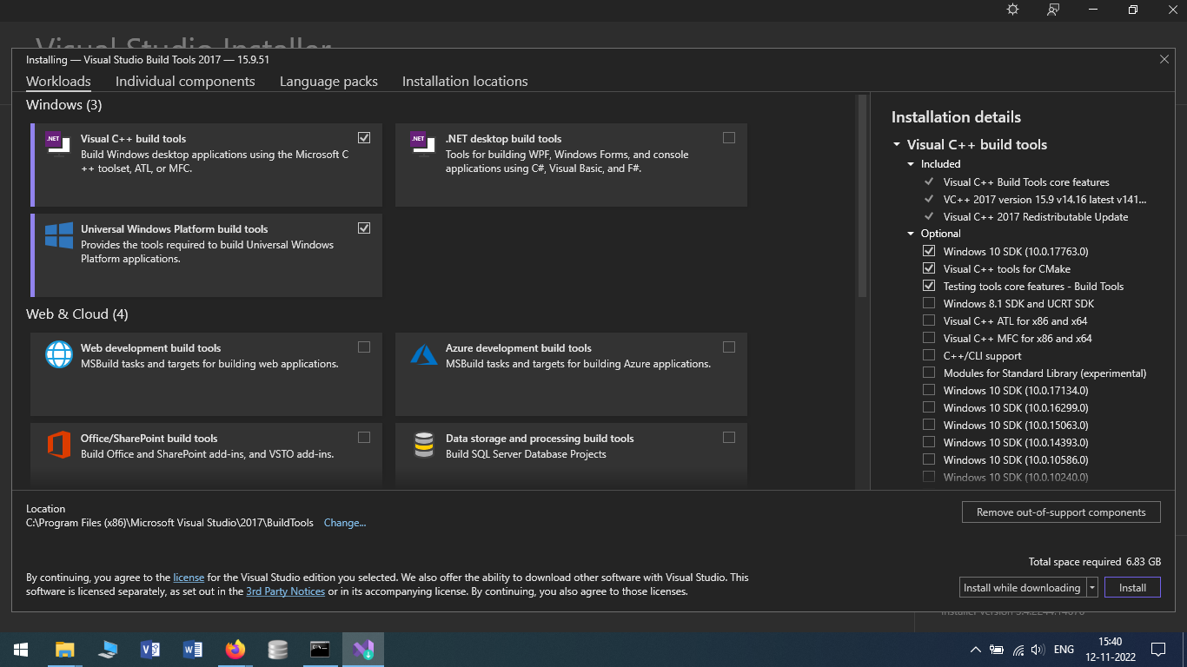

* Select Visual C++ build tool
* Universal windows platform build tool
* To Run Striped blend Electron Application
* Clone the Striped Blend Electron Application \
* Create a folder name StripedblendDatabase inside that folder past the VSTPlugin.bd file then Open the config file in Sequelize folder add the VSTPlugin.db path in config.json file
* 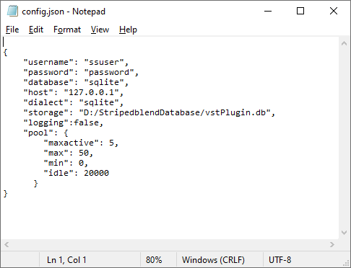
* Visual studio 2017 build tools should be installed
* Open the system environment edit the path add the following path
* C:\Program Files (x86)\Microsoft Visual Studio\2017\BuildTools\MSBuild\15.0\Bin
* 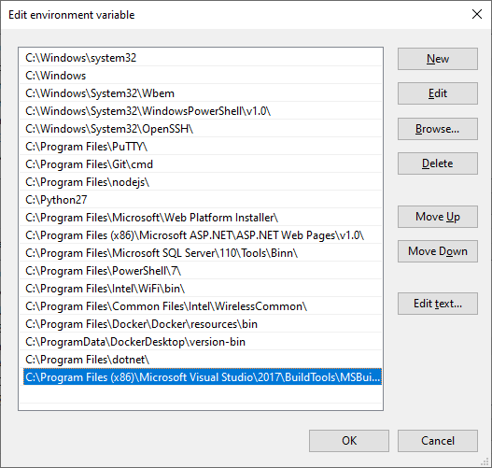
* Open your working drive create a folder named StripedblendSharing
* Open Run Command and enter
* net use y: "\\ANGALAMMA\d$\StripedblendSharing" /persistent:yes
* y- Target drive letter
* d$ - source drive to map
* \\ ANGALAMMA\- your machine name
* \StripedblendSharing - folder to map
* Once the Shared Folder is created Add some file
* Addon-build
* %SnNAPICppStableBuildPath% Run this command To check the latest Addon-build file
* asiosdk_2.3.3_2019-06-14
* VST3 SDK
* Now open the Addon folder Inside they will be some Files Copy the Path
* 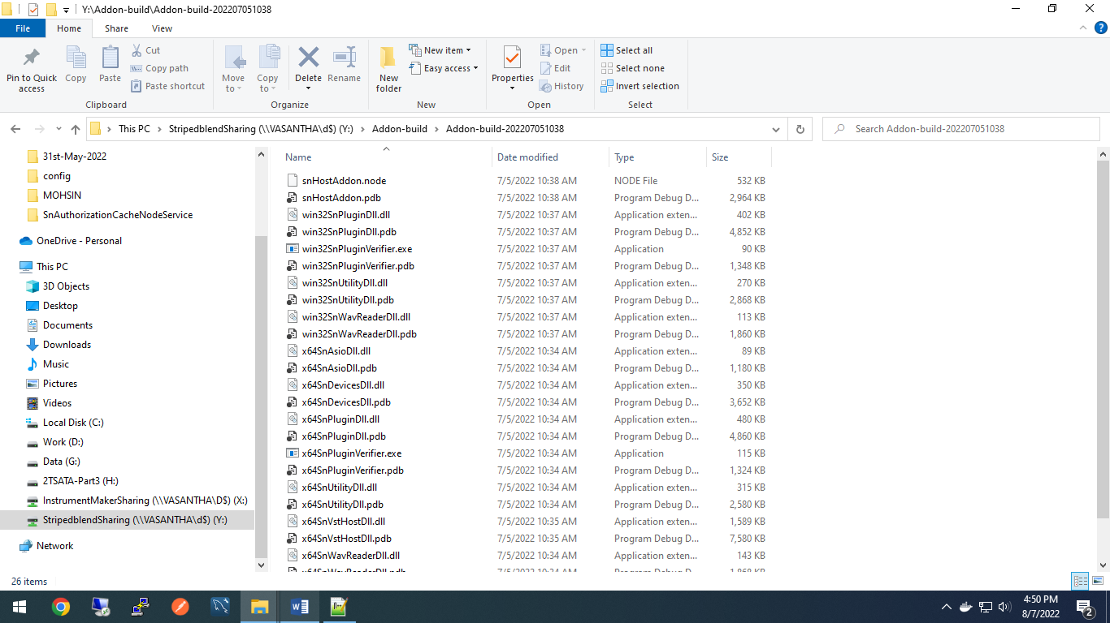
* Open the Environment variables select System variables
* Add SnNAPICppStableBuildPath variable name Add the path of the addon build file’s in variable value.
* 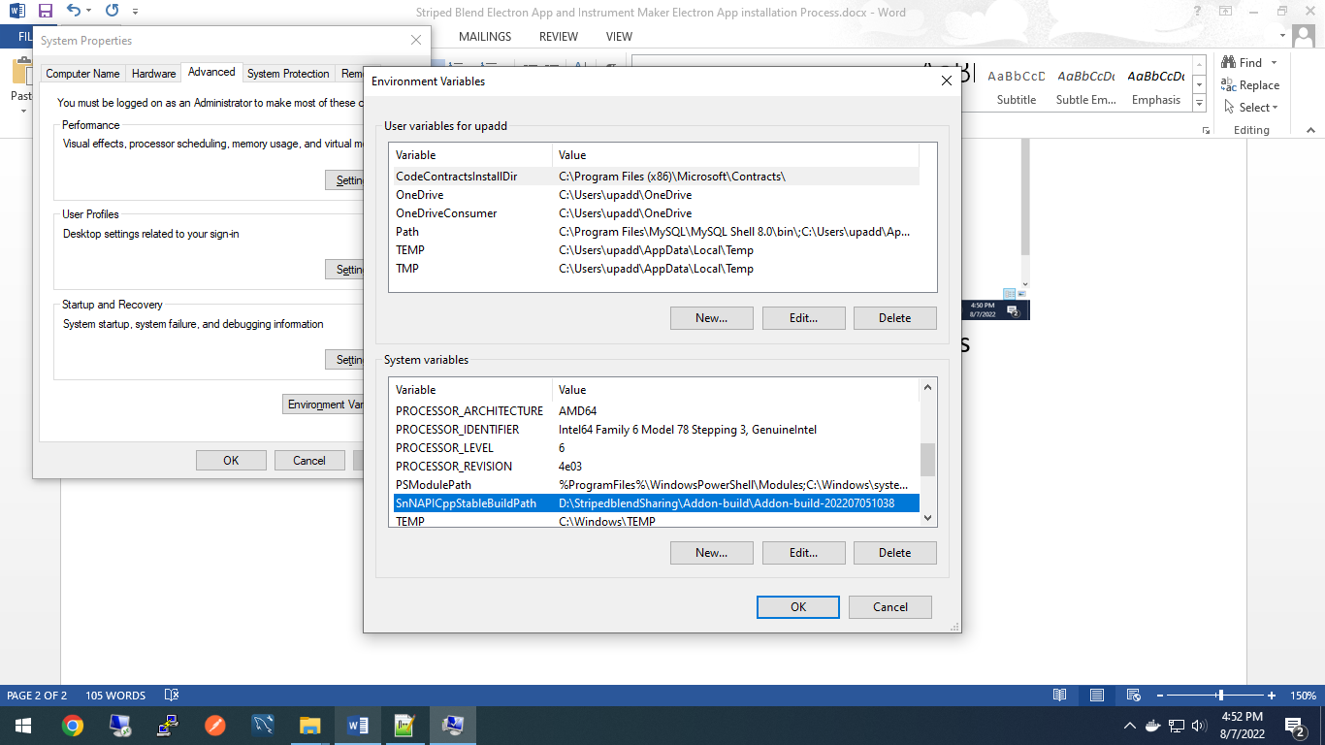
* Run SetupX64 file
* Type y for addon build folder to copy the Shared Folder
* **To Run Instrument Maker Application**
* Clone the app
* In Electron node server Sequelize open the cofig.json file add your database path
* 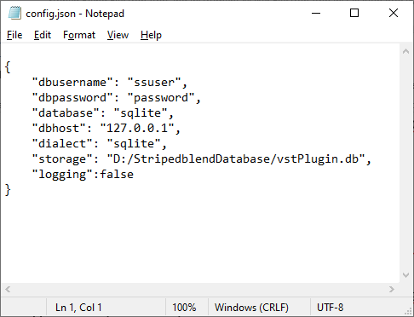
* Create a shared Folder Named InstrumentMakerSharing
* Open run Command
* net use x: "\\ANGALAMMA\d$\InstrumentMakerSharing " /persistent:yes
* x- Target drive letter
* d$ - source drive to map
* \StripedblendSharing - folder to map
* Go to instrument maker project and run the Setupx64 bat file
* Once the application Is open
* TO Add Instruments
* Open File select Set Root Plugin Folder
* Clear all path
* Open dev tool edit the table block
* Element.syle Display :none
* 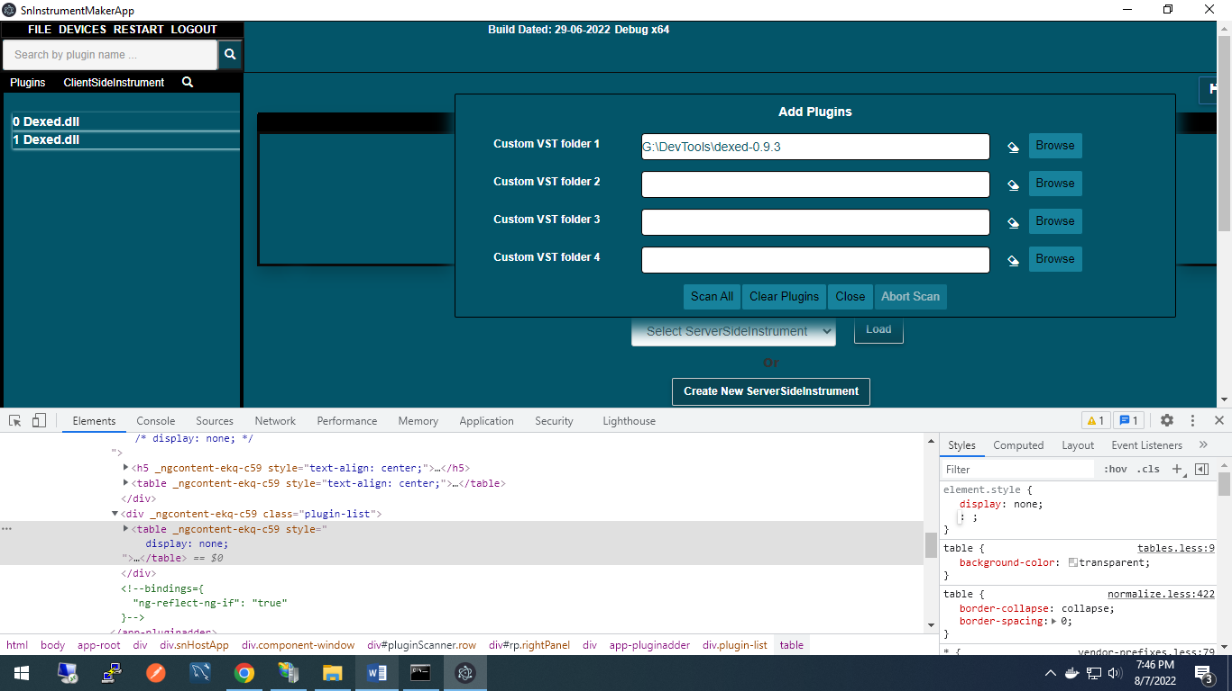
* Click on Browser for Add plugins
* Select and Scan All
* Once the selected plugin showed on Left open the plugin
* Select on Dropdown and load
* Now open the striped blend App The selected instrument will be showing